18.71: a) From Eq. 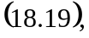

b) 